Rebrand Campaign



Our international office expansion has brought several exciting new changes to Fabrikam. Along with our new ability to reach a global market, our new line of products and services have become the driving force behind our rebrand campaign. We need a greater sense of brand unity across our organization along with an updated corporate identity that’s more consistent with our growing global industry.

Our brand campaign consists of three primary aspects: a new logo, new brand colors, and a continued strive for nature friendly buildings and product manufacturing.

# New Logo

Our research team determined the key to other successful rebrand campaigns was logo simplicity and familiarity. To test that research, our marketing team created five proposed logos that were presented to focus groups familiar with our current branding throughout our markets. Three of the proposed logos were comprised of a dramatic new look and the other two, a simplified version of our old one. Our focus group results confirmed our research analysis and key elements of our old logo have been maintained in order to preserve a sense of familiarity for our loyal customers.

Along with our traditional vertical logo, we’ve add a new horizontal logo. As we are still in the process of rolling out our new brand, please see our team site for guidelines on new logo usage.

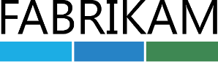

Vertical logo



Horizontal logo

# Brand Colors

Another set of focus groups were conducted to determine our new colors. These groups were not informed of our company and were given a brief overview of our new international products and services.

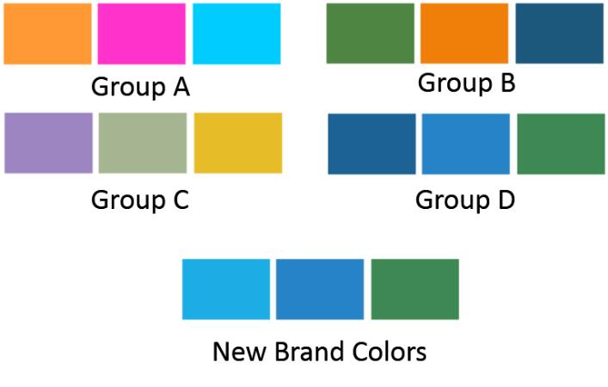As expected, the vivid colors in Group A were well received in our East Asian focus groups. But unexpectedly, those in other regions preferred the familiar blue and green tones of our old brand colors in Group D. Considering the focus group participants were introduced only to a product overview and not our company, this was indeed an interesting discovery.

In order to appeal to all markets, our research team conducted a second focus group for our East Asian markets using color combinations from Groups A and D. Of the choices, fuchsia pink and turquoise were both well received. After careful consideration of all focus group results, we’ve elected to retain the majority of our old colors and introduce turquoise. We believe we’ve successfully achieved our branding goal of simplicity and familiarity while establishing a fresh new look.

|  |  |  |  |  |  |
| --- | --- | --- | --- | --- | --- |
| Group | Strongly Disagree | Disagree | Neutral | Agree | Strongly Agree |
| Group A | 5% | 11% | 16% | 28% | 40% |
| Group B | 40% | 13% | 19% | 8% | 20% |
| Group C | 20% | 25% | 21% | 14% | 20% |
| Group D | 7% | 10% | 12% | 20% | 51% |

# Nature Friendly

While we’ve selected new company colors and created a new logo, our new look is only the first step in our international growth and new opportunities. We believe our continuous core aspect of striving for more nature friendly offices and stores is key to position Fabrikam as the leader in the industry.

Fabrikam supports and promotes fair trade principles in all aspects of our business. From sourcing products across the globe to the retail distribution of the product throughout the world.

Our newly acquired international offices and stores have already taken the necessary steps to become more nature friendly and our goal is to do the same in our locations throughout the United States.

# LEED Certification

LEED certification is the recognized standard for measuring building sustainability in the United States and in many countries around the world and Fabrikam is committed to achieving LEED certification for all new and existing buildings. While our upfront investments will be high, we believe the energy efficient operations of LEED certified buildings will quickly reduce our overhead costs. We also believe this new direction will build a stronger brand presence and strengthen our overall positioning.

Since this is a large investment, our current goal is to update existing buildings and obtain LEED certification for our existing structures over the next four years which will be completed in six phases.

Phase 1 will start with our home location of Oregon and the procedures implemented there will be used as a model for all other phases.

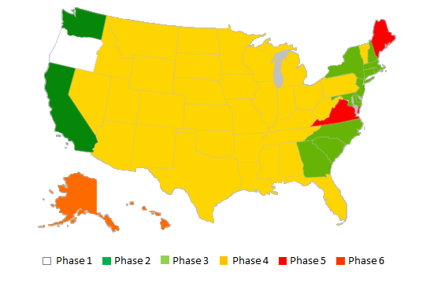

The initial updates will focus on the coastal regions of the United States. Our studies have found these regions are more competitive in the nature friendly marketplace. Phase 4 will consist of our biggest investment as we move inward to the central region. Those states that are part of Phases 5 and 6 are scheduled for the end of our update phase due to the large number of locations in these areas. Our estimates have determined we will have recovered our initial investment and overhead costs will have decreased by the time these 236 locations are slated for update.

# Nature Friendly Products

All new buildings will be constructed with nature friendly materials, appliances, supplies, and furniture such as those in the following list:

## Sustainable products

* Bamboo
* Rattan
* FSC certified wood

## Other materials

* Recycled
* Salvaged
* Refurbished
* Remanufactured
* Corn based resins

## Fixtures and appliances

* Water saving aerators
* Dual flush toilet systems
* Energy star appliances

## Miscellaneous

* Combination water cooler/bottle filler
* Porcelain or enamel plates and utensils
* Compostable cups, plates, and utensils

Existing structures will incorporate these items on a replacement basis. While we would like all structures to be 100% nature friendly within the next four years, we also believe it’s equally nature friendly to not add to our landfills unnecessarily.